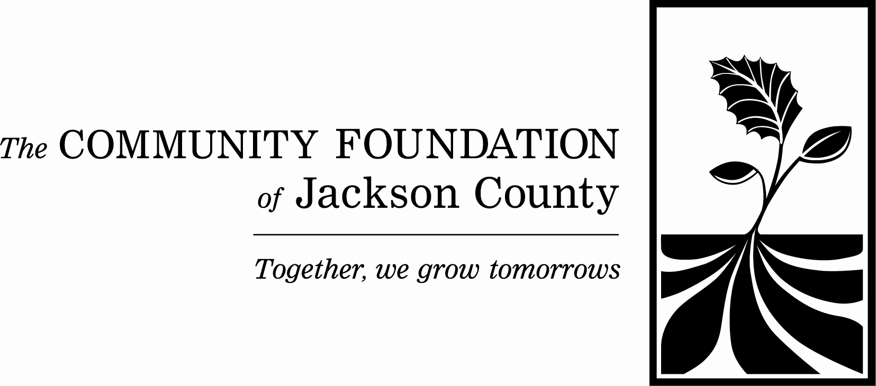

Donald J. Klaes Classroom Education Grant Program
2025-2026 Proposal Form

Please read the Community Foundation of Jackson County’s Classroom Education Grants guidelines before beginning the proposal process. The grant proposal process is easy and the grant is awarded directly to the applicant. A teacher may apply for more than one grant if he/she has many ideas. All teachers may apply, including special needs teachers, music, art, etc. Projects that appear to have already begun or are funded elsewhere will not be accepted. Please note that, if funded, a narrative and financial report, with receipts attached, will be required. Keep in mind that many Jackson County schools are participating in this endeavor. Since the Foundation has a limited amount of money to work with, not all good ideas will be funded. The maximum grant awarded is $400.00. Please contact the Community Foundation office if you have further questions.

Proposals must be received no later than November 1, 2025

Date submitted

Teacher’s name
Teacher’s e-mail address
School
Address
Phone number
Grade level/Subject
Number of students
Amount requested

Principal’s signature

Please provide the following information regarding this grant request, using the space provided.

- A description of the project including goals/objectives:

2. Projected dates of project beginning and ending:

3. Will this project be implemented one time, or can it be repeated in subsequent school years?

4. If the cost of the project is more than the amount requested, how will you fund the remaining balance?

5. Please attach an itemization of expenses.

**Please note: Grants will not be awarded to the same applicant for the same project more than once.**

